EXPERIMENT-7
7)Perform basic video processing operations on the captured video. Read captured video in python and display the video, in slow motion and in fast motion.
a) CODE
import cv2, os
d = os.path.join(os.path.expanduser("~"), "Desktop")
for n,s in [("NORMAL",30),("SLOW",100),("FAST",10)]:
v = cv2.VideoCapture("video.mp4")
w = cv2.VideoWriter(d+"/"+n+".mp4",
cv2.VideoWriter_fourcc(*"mp4v"),30,
(int(v.get(3)),int(v.get(4))))
while True:
r,f = v.read()
if not r: break
cv2.putText(f,n,(20,40),0,1,(255,255,255),2)
w.write(f)
cv2.imshow(n,f)
if cv2.waitKey(s)==ord('q'): break
v.release()
w.release()
cv2.destroyAllWindows()
print("Saved to Desktop")

b) INPUT
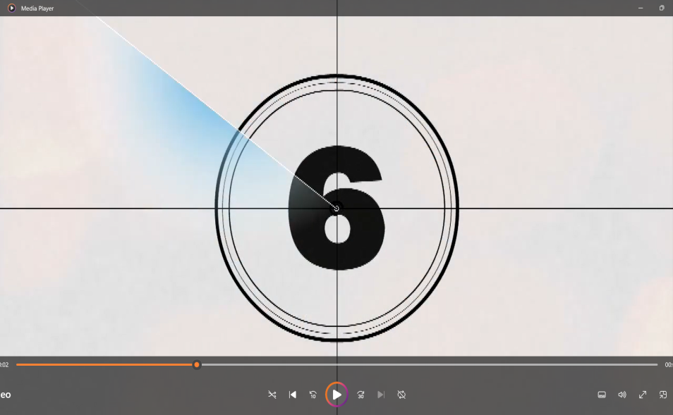
c) OUTPUT
